Assignment on subroutine: COAL FALL 2026 Section A, B,
Instructions:
Due date: 23 Oct 2026
Submit each question as separate file in a folder, DONOT ZIP YOUR FOLDER/FILES
Name your folder as you roll number like XXLXXXX
Name of the file will be number of question like QuestionX
DONOT SHARE YOUR CODE WITH ANYONE.
DO NOT COPY ANYONES CODE.
DO NOT PLACE YOU CODE AT UNSECURE LOCATION

Question 1:
Write a function names statsOfArray that takes an array as input and returns its min, max and median as output.
All the input and output parameters should be passed on stack.
You cannot sort the array in statsOfArray function, however, you can call BubbleSort function in
statsOfArray.
Template of this function is give below, you code should work for every array.
; Question 1 template Assignment 2
[org 0x0100]
jmp start
array1: dw 6, 7,3, 9, 100, 5, 1, 50
lenArray1: dw 8
statOfArray:
; this function will take one array as input
; and will return min, max and median of array.
; median is the middle element of sorted array
; write your function here
start:
; make space for o/p
; push inputs for array1
call statOfArray
pop ax ; ax should be min of array
pop bx ; ax should be max of array
pop cx ; ax should be median of array
mov ax, 0x4c00
int 21h

Question 2:
Write a function printNumbers that take multiple numbers on stack as input and prints them on screen. The function also takes total numbers to be printed as input.
For example if numbers to be printed are 134, 189, 156 then call to printNumbers will be as follow
Start:
Push 134; first number to be printed
Push 189; second number to be printed
Push 156; third number to be printed
Push 3; total numbers to be printed
Call printNumbers
The screen should look like this after this call (be careful about the order in which numbers are printed, it should be same as shown on screen i.e number at end of stack is printed on first line and vice versa )
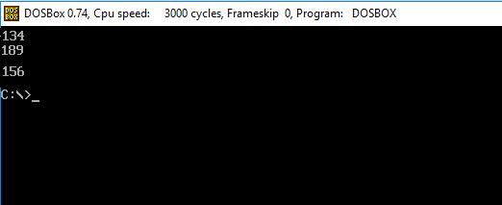
You can used printNumber routine given in book for this question, and call it multiple times in printNumbers function.
Your function should work with any number of inputs not just 3 inputs

Question 3:
Write an infinite loop that shows A moving from top left to middle and B from top right to middle of the screen and then back simultaneously. Use two empty nested loops with large counters to introduce some delay so that the movement is noticeable.
Next few figures show this code in action
- Start with A and B in top left and right corners resp.
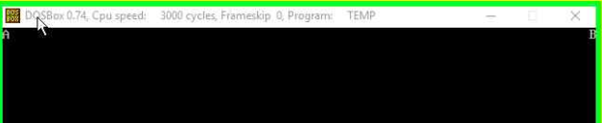
- Moving towards center
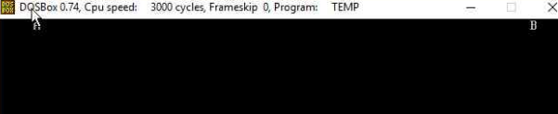
- A and B Meeting at center
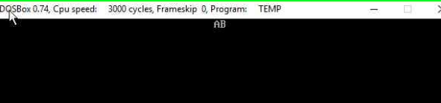
- A and B Moving towards their respective corners again
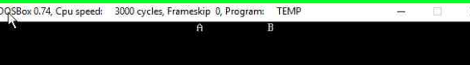
A and B will keep moving like that infinitely

